6.5 Properties and Applications of Matrices

Matrix Notation

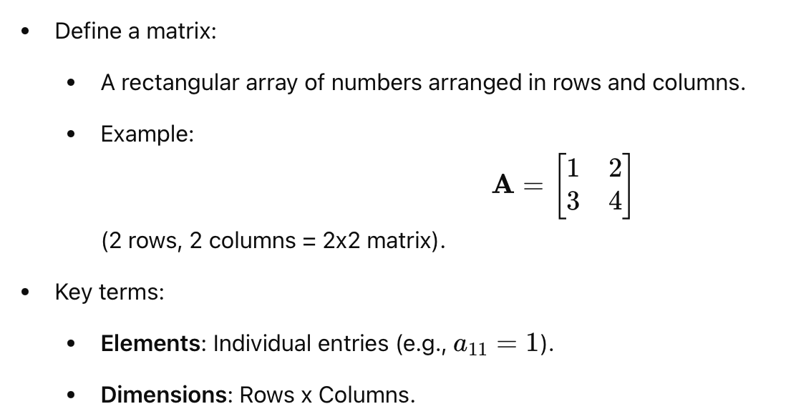

Given the matrix A, what is $a_{31}$?

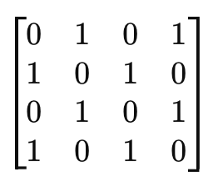

Example
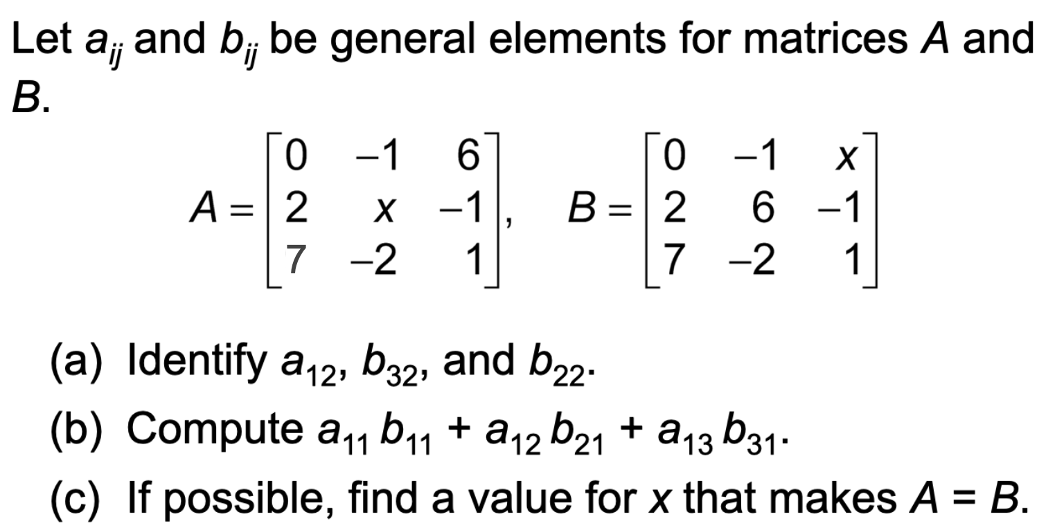

Application of Matrices to Social Networks
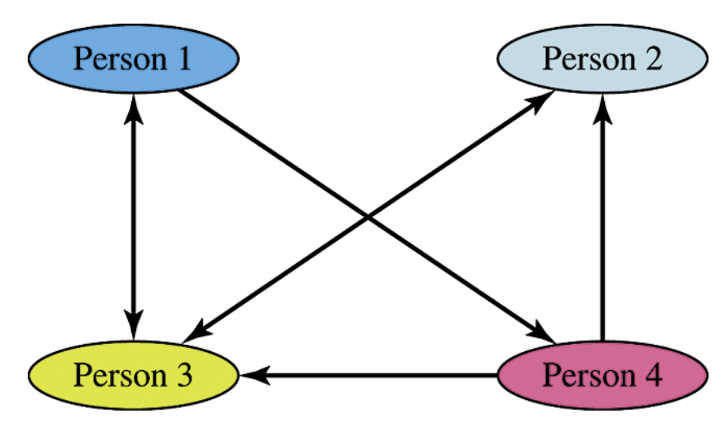

Example. Representing Social Networks as a Matrix
Represent the social network above as a matrix. If Person x likes Person y, then the x,y entry in the matrix is 1. If not, then the entry is 0.

Matrix Operations

Matrix Addition
The sum of two m × n matrices A and B is the m × n matrix A + B, in which each element is the sum of the corresponding elements of A and B. This is written as
A + B = [a_{ij}] + [b_{ij}] = [a_{ij} + b_{ij}].
If A and B have different dimensions, then A + B is undefined.

Matrix Subtraction
The difference of two m × n matrices A and B is the m × n matrix A − B, in which each element is the difference of the corresponding elements of A and B. This is written as
A − B = [a_{ij}] − [b_{ij}] = [a_{ij} − b_{ij}].
If A and B have different dimensions, then A − B is undefined.

Multiplication of a Matrix by a Scalar
The product of a scalar (real number) k and an m × n matrix A is the m × n matrix kA, in which each element is k times the corresponding element of A. This is written as
kA = k[a_{ij}] = [ka_{ij}].

Example. Performing Operations on Matrices
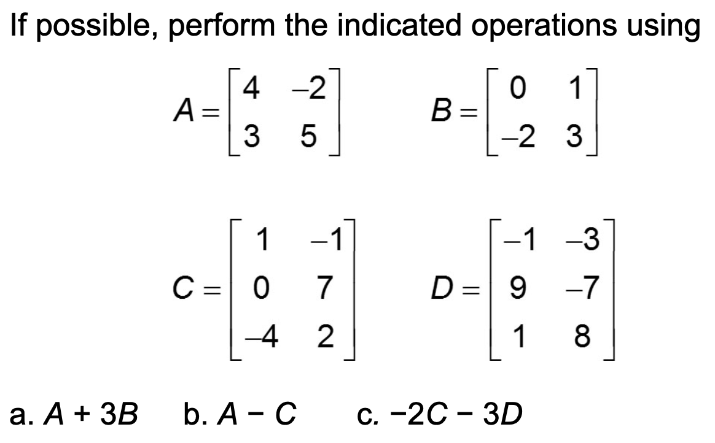
Matrix Multiplication

The product of an m × n matrix A and an n × k matrix B is the m × k matrix AB, which is computed as follows. To find the element of AB in the ith row and jth column, multiply each element in the ith row of A by the corresponding element in the jth column of B. The sum of these products will give the element in row i, column j of AB.

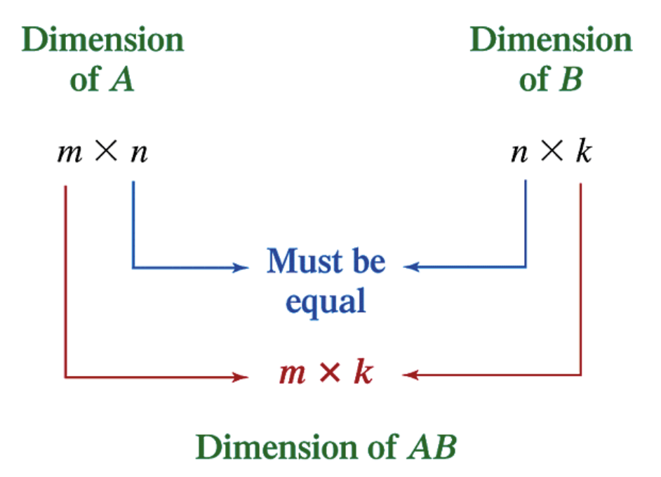

Example. Multiplying Matrices
